MANAGEMENT PLAN and evolution OF THE AIM GAMES PROJECT

Software Engineering & Professional Practice

**Group 7 AIM GAMES PLATFORM**

Arenas Arenas, Antonio

Bizcocho González, Mario

De la Fuente Bonilla, Fco. Javier

Monteseirín Puig, Alejandro

Molina Domínguez, Jorge Manuel

Pazo Jiménez, Pablo

Pérez Piñero, Iván

Santos Batista, Miguel

Content

Version History 3

1. Project justification 3

2. Core use cases and MVP 3

2.1 Core uses cases 3

2.2 MVP 3

2.3 Uses Cases added and changed after Pilot plan 4

2.4 Mock-ups and UML 4

2.5 Demonstration of MVP 4

2.6 Promo video 4

2.7 How to reproduce the user cases 4

3. Cost and profit analysis 6

3.1 Costs 6

3.1.1 Direct Costs 6

3.1.2 Indirect Costs 7

3.1.3 Reserves 7

3.1.4 Benefit 7

3.1.5 Summary 8

3.2 Profits 8

3.3 Evolution of personal costs after the First Sprint 10

3.4 Evolution of personal costs after the Second Sprint 11

3.5 Evolution of the personal costs after the Third Sprint 12

4. Development plan 13

4.1 SWOT 13

4.2 Methodology 13

4.3 Declaration of versions and deliveries 14

4.4 Sprints Planning and First Sprint Plan 14

4.5 First Sprint Execution 16

4.5.1 Principal Problems and solutions 16

4.5.2 Conclusions and lessons learned from the retrospective Sprint 17

4.5.3 Second Sprint development plan 18

4.6 Second Sprint execution 19

4.6.1 Principal Problems and solutions 19

4.6.2 Changes to the previous Second Sprint plan 20

4.6.3 Conclusions and lessons learned from the retrospective Sprint 20

4.6.4 Third Sprint Development Plan 20

4.7 Third Sprint Execution 20

4.7.1 Principal Problems and solutions 21

4.7.2 Third Sprint Development Plan 21

4.7.3 Conclusions and lessons learned from the retrospective sprint 22

5. Technologies 22

6. Quality Report 23

7. Team Composition 23

7.1 Explanation of slide of team composition of the attached PowerPoint 24

8. Productivity metric and Punishment System 24

8.1 Productivity metric 24

8.2 Punishment System 24

9. Pilot study 25

9.1 Studios 25

9.2 Users 25

9.3 Open Beta 25

10. Piloting Plan 26

10.1 Overview of the decided changes from the feedback 26

11. Competitor analysis 26

12. Differentiation 27

13. GDRP 28

14. Code repository and deployed application 28

15. Charter of commitment 29

16. Signed in conformity 29

# Version History

|  |  |  |  |
| --- | --- | --- | --- |
| Version | Author | Changes | Date |
| 1.0 | Jorge Manuel Molina Domínguez | Initial version | 03/14/2019 |
| 1.1 | Jorge Manuel Molina Domínguez | Added First Sprint documentation and changed title | 03/29/2019 |
| 1.2 | Jorge Manuel Molina Domínguez | Added Second Sprint documentation and changes | 04/12/2019 |
| 1.3 | Jorge Manuel Molina Domínguez | Added Third Sprint Documentation and changes | 05/03/2019 |

# Project justification

Videogame development companies do not have easy access to different resources (graphic engines, courses on any technology, 3D assets, etc ...) or sufficiently qualified staff or people interested in the development of video games despite existing more than 1000 national studios.

With this service application, AIM GAMES seeks to be the meeting point and search for all companies or people looking to work in the world of video games offering various resources and organizing different events or challenges.

# Core use cases and MVP

## Core uses cases

An anonymous actor can register to the system as a business or a freelancer

A business can create job offers

A business can pay to have access to all the features of the application

A business can list the curriculums posted by the freelancers

A business can see the details of the curriculums

A business can open a new thread in the forum

A business can answer to an existing thread of the forum

A freelancer can list all the job offers created by the businesses

A freelancer can create his own curricula with a high level of detail

An administrator can verify curricula

An administrator can take down fake/spam/inappropriate offers and curricula.

## MVP

An administrator can create and ban any type of actor in the admin panel

An administrator can create events.

A manager can create Tags and Graphic engines in the admin panel

A manager can verify curricula

A business can join an event advertisement

A business can post a challenge that freelancers can fulfil to opt in for a job

Every freelancer or business can see the events posted by the business

Every freelancer or business can send messages to other actor

An anonymous actor can login into the system with an existing account.

## Uses Cases added and changed after Pilot plan

As a freelancer I can pay for have preference my curriculum in the searches of curricula

As a business I can pay a normal or premium subscription to get coins with I can use the different uses cases.

As a business without a subscription can only see the list of Curricula, forum, job offers, challenges, Events and can use the message system.

## Mock-ups and UML

Look attached folder Mock-ups and the UML

## Demonstration of MVP

Look attached PowerPoint at the slide 11, there is a camera icon with the link to the demo video and at the README.

## Promo video

Look attached PowerPoint at the slide 1 for the promotional video, click in “Watch the advertisement” and at the README there is the link

## How to reproduce the user cases

Remember that in the attached README are every needed account information.

We will group the user cases in user type.

**No registered:**

Can only see our Terms and Conditions, the home page and Log in or register in the system clicking at Log In in the menu.

At the Log In page you can sing up like a freelancer or business, you only need to complete the form with correct data and will be redirect to the main page.

In the case that you register like a business, you will be redirect first to PayPal to pay the necessary fee.

**Administrator:**

If you are log in like and administrator, you will be redirect to the admin panel of Django where you can create or delete everything.

**Freelancer:**

If you log in like a freelancer, you will have access in your menu to:

your curriculum where you can add information about your experience, the html5showcase its limited with the use of iframe to load the showcase, to know more about it read our terms and condition to know more about its limitations.

In the curriculum you can have a button to pay an only pay to preference in curriculum searches

Job offers where you can see every offer created by business. The details of the offers and can send a message to their email to apply for it.

Challenges like with job offers created by business, and you can response to their challenges and win prizes.

Events, where you can see every event created by the administrators, and you can join or disjoin of them in the event detail view.

Messages, this is where you can send messages to every actor of the system, if you don’t want to send messages with you real email, this work like an online chat.

**Business:**

If you log in like a business and have a subscription, you will have access in your menu to:

Forum, where you can post anything to offer to the community and other business, and you can respond to the threads of other.

A list of curricula where you search the freelancers that you need and send them messages to contact with them, to see their showcase you only need to load them and confirm.

Job offers where you create job offers if you don’t find the needed freelancers, and see every job offer of other business

Challenges, where you can create challenges to test the interested freelancers and with this you can have a pre-job interview filter, or you can truly put some prize to publicise yourself.

Events, where you can see every event created by the administrators, and you can join or disjoin of them in the event detail view.

Messages, this is where you can send messages to every actor of the system, if you don’t want to send messages with you real email, this work like an online chat.

Manage subscription, where you can change/cancel your subscription or buy coins if you have used all

If you have not a subscription:

You will have only access to the list, but not details, of Forum, Curriculum, Job offers, Challenges, Events.

You will can see and join the events

And in Manage Subscription you can pay for one of two version of monthly subscription of 15€ or 30€ that give different amount of coins (standard and premium) and buy coins

**Manager:**

If you log in like a manager, which is only possible if you receive an manager account from an administrator, you will have access to a list of curricula where you can verify them, and a limited admin panel of Django where you can create new Tags or Graphic engines, that can be used in curricula of the freelancers and messages where you can send messages to every actor of the system, if you don’t want to send messages with you real email, this work like an online chat.

# Cost and profit analysis

## Costs

### Direct Costs

**Personnel costs**

The personnel costs are the result of the sum of the gross salary and the social costs (business share, different taxes, etc..) which is near a total 29,9% according to the current laws for the year 2019.

The 8 team members will have a work load of 150 Hours per member and the total personnel costs will be:

|  |  |  |  |  |  |  |  |
| --- | --- | --- | --- | --- | --- | --- | --- |
| Name | Roll | Cost/hour | |  | | --- | | Inverted hours | | Gross Cost | Social costs | Total |
| De la Fuente Bonilla, Fco. Javier | CEO, Project Manager | 25€/h | 150h | 3750€ | 1124.63€ | 4874.63€ |
| Molina Domínguez, Jorge Manuel | CCO, CIO | 22,73€/h | 150h | 3409,5€ | 1022.51€ | 4432.01€ |
| Bizcocho González, Mario | CMO, Speaker | 22,73€/h | 150h | 3409,5€ | 1022.51€ | 4432.01€ |
| Monteseirín Puig, Alejandro | Full-stack Developer | 18,54€/h | 150h | 2781€ | 834.03€ | 3615.03€ |
| Pérez Piñero, Iván | Backend Developer | 15,37€/h | 150h | 2305.5€ | 689.35€ | 2994.85€ |
| Arenas, Antonio | Frontend Developer | 15,37€/h | 150h | 2305.5€ | 689.35€ | 2994.85€ |
| Santos Batista, Miguel | Full-stack Developer | 18,54€/h | 150h | 2781€ | 834.03€ | 3615.03€ |
| Pazo Jiménez, Pablo | Backend Developer | 15,37€/h | 150h | 2305.5€ | 689.35€ | 2994.85€ |
|  |  |  |  | **23047,5€** | **6905.76€** | **29953.26,75€** |

**Other direct costs**

Quality control reports may have an impact on several tasks, and 10% of the total gross salary is applied to cover this cost, being in total 2304,75€

We consider a cost of 0€ in maintenance because that job will be done by members and volunteers of the association

**Summary of direct costs:**

|  |  |
| --- | --- |
| Gross salary Costs | 23047,5€ |
| Social costs | 6905,76€ |
| Other direct costs | 2304,75€ |
| **TOTAL Direct costs** | **32258,01€** |

### Indirect Costs

For the indirect costs generated by the personal work of the project and basic needs in fungible material, a charge of 1% of the direct costs will be applied, totalling 322.58€

### Reserves

A 10% reserve is applied to cover the personnel costs generated by the possible increase in working hours due to problems during the development, totalling 3258.06

### Benefit

According to the experience of the team in this type of projects and high competence in development of web information system it is decided to apply a 15% benefit on the direct and indirect costs of the project, 4887,09€

### Summary

|  |  |
| --- | --- |
| **Concept** | **Amount** |
| Direct costs | 32258,01€ |
| Indirect costs | 322,58€ |
| Reserves | 3258,06€ |
| Benefit | 4887,09€ |
| Total without VAT | 40725,74€ |
| VAT (21%) | 8552,41€ |
| **TOTAL** | **49278,15€** |

## Profits

The first and bigger return of capital can come from aids from the Ministry of Culture and regional governments because we are an association, we are eligible for “Aid for action and cultural promotion” (http://www.culturaydeporte.gob.es/servicios-al-ciudadano-mecd/catalogo/cultura/becas-ayudas-y-subvenciones/ayudas-y-subvenciones/industrias/accion-promocion-cultural.html

), this aid can give us from 10000€ to 90000€, numbers that can cover an important or the total part of the initial cost.

The second way to get capital is give sublicense administrative access to other associations to create a partnership with them which will result in the association growing more.

The last initial way to get capital and the principal one is a company membership fees plan which we will offer personalized rates to different companies because not every small company can pay the same than bigger ones. With this membership, the companies will have access to everything that we have to offer.

One example is the next one:

In the graphic we can see different companies that we offer different prices

These companies are only an example of possible clients that we have asked how much they would pay for a service like ours.

But we will offer 2 different prices, 15€ and 30€ monthly, with this we think that we will attract more studios that have less resources and the possibility to buy coins, the new system to use the features of the system, 3€ each

If the aids from state and regional governments are considered, and we project a conservative studio subscription rate, we can expect to fully cover the cost of the project by the 3rd quarter of the 3rd year in the market.

## Evolution of personal costs after the First Sprint

We will focus at how have incremented the cost of the personal cost because it’s the only important thing in the budged that can have big variations from the estimated.

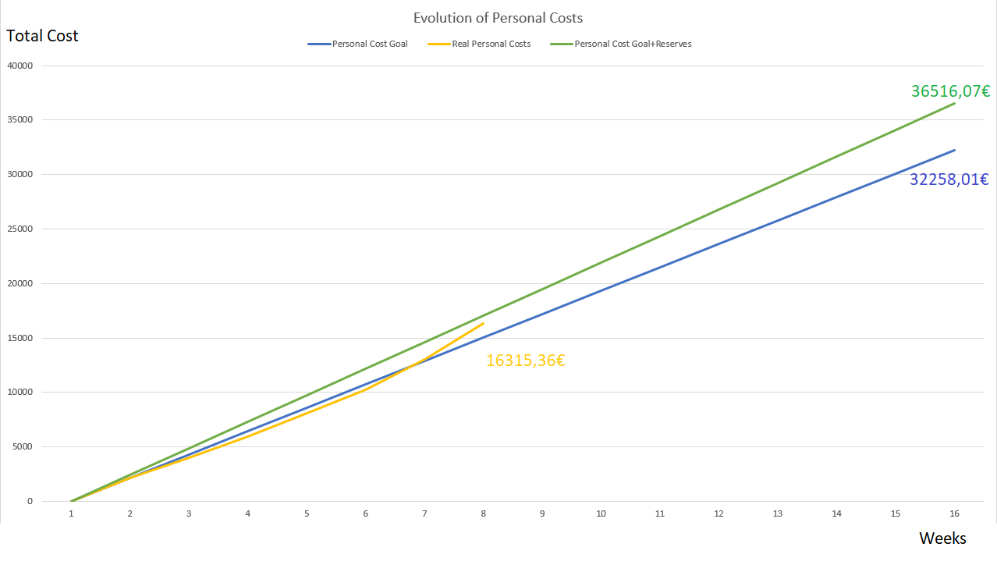

We had estimated a personal cost of 32258,01€ (the blue line)

Like we can see with the yellow line (the real personal cost), during the time previous of the first sprint we only variated positive from the estimated but when we started the first sprint we have saw that we worked more from the estimated because we are using a new technology and didn’t predicted correctly how much time we would consume in the task.

Despite everything we are at least in the range of the budget that contemplate the reserves for this type of problems, that joined with the estimated personal cost are a total of 36516.07€ (green line).

## Evolution of personal costs after the Second Sprint

We will focus at how have incremented the cost of the personal cost because it’s the only important thing in the budged that can have big variations from the estimated and the completion of the project.

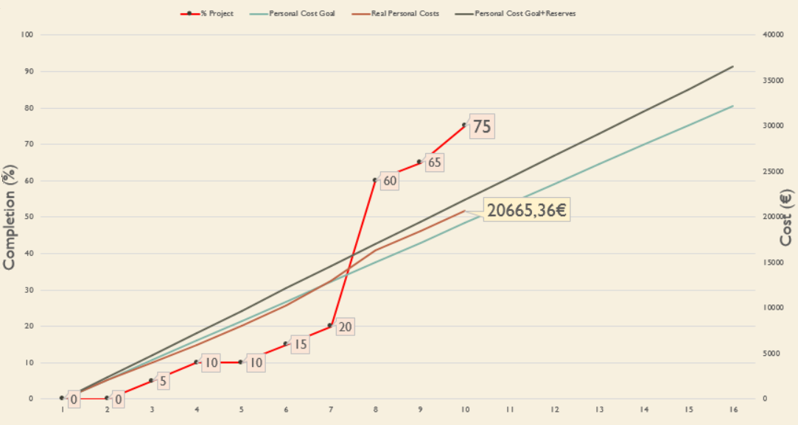

We had estimated a personal cost of 32258,01€ (the green water line), and a total (personal plus Reserves of 36516.07€ (brown line) if we include the reserves.

Like we can see with the orange line (the real personal cost), and compare it with the 1º sprint graphic we can see that in this second sprint we have got closer to the estimated cost, this is because while the 1º sprint we have develop the most of user cases because of what we thought of what were core or not, so in this second sprint we only needed to develop only a little more and fix any bug, and the experience gained from the 1º sprint, every task of development have been completed in less time and it let us to use more time with testing the system.

We have included a new value to the graphic, the % completed of the project (red line) and this value is about the all project and not only the development of it.

We can see that at the until the 6º week, we had little progress, this is because these weeks were about the devising of the project, after it we can see that we jump 15% to 60%, in the 2 weeks of the first sprint, this is because at that moment we categorized the most of our uses cases like core uses case, because there were what we thought that were important to the piloting plan, after it and in the last 2 weeks of the second sprint we jump to the 75%, point in were we have completed the piloting plan and our mvp, being the last 25% the enhancement of the mvp with the received feedback, the prepare the project launch and finishing the business plan.

## Evolution of the personal costs after the Third Sprint

We will focus at how have incremented the cost of the personal cost because it’s the only important thing in the budged that can have big variations from the estimated and the completion of the project.

We had estimated a personal cost of 32258,01€ (the green water line), and a total of 36516.07€ (brown line) if we include the reserves.

Like we can see with the orange line (the real personal cost), and compare it with the 2º sprint graphic we can see that in this third sprint we have got closer to the estimated cost, this is because we had no problems from the second sprint, and only had to implement the changes we considered after the piloting plan, and were less than we predicted that could be at the start of the project and every task of development have been completed in less time and it let us to use more time with testing the system.

About the progress, the red line, we can see that we have jumped to 85% because we consider that we have finished the development of the project, and we only left the business plan and prepare the project launch

# Development plan

## SWOT

To know how we should organize ourselves in order to be successful:

Like we can see we have more Opportunities than threats, so we have great hopes for the success of our project.

With the main immediate risk that is the lack of knowledge of some technologies, we have started to solver it with the start of a learning plan for Django at the start of the 1º Sprint

## Methodology

We will work with Scrum for the duration of the 3 Sprints of 2 weeks each. At the start of the sprint we will create the sprint backlog and have a sprint review each Wednesday, and the next day of delivering the progress to the teachers of ISPP, we will have the sprints retrospectives.

We will use Telegram for the immediate communications of the team, and Discord for every reunion that can’t be done face to face.

For the project management we will use Trello and its formula of Kanban board.

For the time management we will use clockify because it has a free extension for Trello.

For documentation management we will use Google Drive.

And for code repository we will use GitHub.

## Declaration of versions and deliveries

In our landing page, https://aim-games-landing-page.herokuapp.com/, one can have access to every version delivered to the professors of SEPP.

Every new version will have an URL with this format, https://aim-games-X.herokuapp.com/, being X the iteration number, and in each web will has in the footer the version of the web

## Sprints Planning and First Sprint Plan

The first Sprint, March 18-29, we will develop the core uses cases, in the second Sprint, April 1-12, we will finish the develop of the MVP, and we will start a pilot plan to get feedback and at the third Sprint, April 22- May 3, we will polish the MVP with the feedback that we will have obtained during the pilot plan.

After a first meeting It was decided the following first Sprint planning:

**Django Basic Course:** The majority of the team is inexperienced at Django, so a basic course will be conducted by Alejandro Monteseirín, whose knowledge of the technology is greater than the rest of the team. It is foreseen an average duration of about 3 hours that will be carried out as the first activity of the sprint to have a base to work on.

**Planning**: At the beginning of the sprint and together with the course of Django, the small modifications to the previous planning that may arise after the course and the first impressions of Django will be adjusted.

**Preparation of Django's functional template and deployment in Heroku**: In conjunction with the basic course, Alejandro Monteseirín will be responsible for preparing a base template for the project on which the entire team will work. In addition, it will deploy this template in Heroku to be able to do so without worrying about maintenance tasks of the servers.

**Models:** Pablo Pazos will be responsible for the implementation of the project models, this being one of the most complicated tasks of the project and thus deciding a duration of about 7 hours that will be developed throughout the first week of the sprint.

**Login**: Miguel Santos will be responsible for this task that includes both the page to register in the application and the corresponding to access it from each of the roles.

**Main Menu**: This requirement is implemented by Iván Pérez and will develop the entire view of the page of users who have just accessed the application.

**List of resumes, job offers and threads:** Antonio Arenas will develop all these lists. The planning of hours carried out corresponds to a foreseeable lack of experience in the first of the lists to be developed and the consequent speed acquired for the following.

**Post Thread (company):** Mario Bizcocho will combine his role as speaker with this requirement since, being our Product Owner in our Scrum configuration, he knows the ins and outs of the forum and the needs of the company. When having to reconcile with another role, this will be your only development task.

**Post Message (company):** Aided by the feedback of our Product Owner, this requirement will be developed, which is supposed to take about 3 hours since Iván will have previous experience with the main menu and it should not be a problem.

**Create Curriculum and view curriculum:** Fco. Javier will develop both requirements when dealing with all about curricula. A total of 6 hours is calculated for the entire process of both.

**See Threads**: Alejandro Monteseirín with the experience acquired in the past on Django will be in charge of being able to visualize the threads of the forum. It is estimated about 4 hours since, despite being able to do it in a considerably less time, it has been preferred to leave the planning in order to use part of that time to help the rest of the team with doubts about Django.

**Pay (company):** Iván Pérez, with the experience gained in carrying out his previous requirements, will work under the supervision of Alejandro Monteseirín to develop the payment of the companies. The 3 hours calculated for this requirement are almost entirely for the action itself to pay as there will be little incidence in terms of views and these can be done quickly.

**Fill database:** Jorge Manuel will do this task in combination with his CCO role. Due of his great occupation in his other role, he will only take care of this task. Although it is a heavy task, it is repetitive and does not require much specialization in any technology so it has been calculated that in about 3 hours must be finished.

Throughout the sprint, management tasks will be carried out if a change in the initial planning is necessary, as well as various testing tasks will be carried out. It should be noted that the team has decided to take their planning to finish the sprint 3 days before the official end of the sprint in order to face any eventuality.

## First Sprint Execution

**We have finished with success the first sprint because we have completed all the task that we had contemplate for it.**

During the first sprint we have done a sprint review at Friday 22 to look at how is going the sprint and pinpoint the problems that have been showing up to decide what to do to get a solution.

Finishing the sprint, we have done a reunion at Friday 29 to do the sprint retrospective and sprint planning for the second sprint.

The meeting minutes of both meetings are the in the attached folder Meeting Minutes.

### Principal Problems and solutions

During the development we have found some problems, but the principals ones were:

**1º Need of a populate scrip:**

At the beginning of the development we found ourselves in the situation of having to restore the database every time there was a change in the models due to finding an unexpected bug.

This produced the tedious waste of time having to re-fill the data base in order to re-test some functionality.

In the sprint review it was decided to change the task of filling the database of Jorge Molina, to the creation of a script that allows to inject data into the database easily and quickly.

**2º Problems with PayPal:**

During the implementation of PayPal, the question arose as to how to integrate the payment system.

After several meetings between the full-stack-developers it was concluded that it should be done during the registration of companies since payment is necessary for the registration of the company to be considered valid.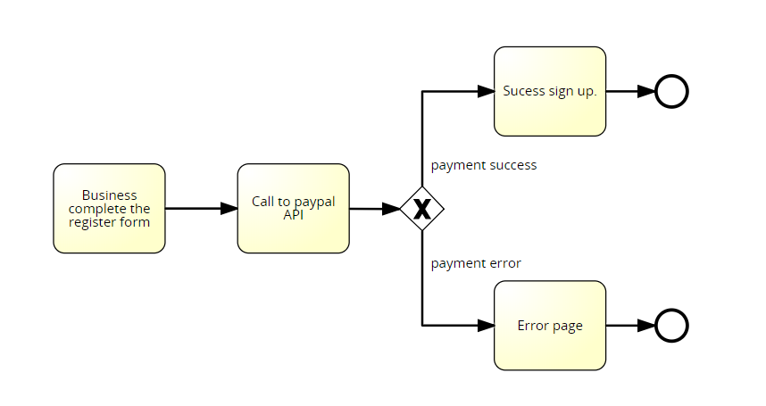

-flow of the solution decided for the integration of PayPal payment.

**3º Problems with Git:**

In the beginnings of the project some problems arose with the use of git (mainly conflicts), which considering the automatic deployment of Heroku, were priorities to fix. For that reason, a flow was decided that all the members of the group must follow for the correct functioning:

1º Pull project

2º Creation of local Branch

3º Add functionality / work on the project in that branch

4º Local testing

5º Pull and merge with the local branch

6º Push, once checked that everything works

### Conclusions and lessons learned from the retrospective Sprint

We have had a hard first spring because the learning and use of a new technology and some minor coordination problems, but we could give solutions to every trouble that have been showing up.

We had several problems regarding conflicts because we were not using a defined structure of branches for developing our application and our main branch (where we all committed), was the one auto deployed in Heroku, also this made the Heroku database really unstable and we had to reset it several times. In order to fix this, we created a populate file so we could easily reset and fill the database within seconds. For the second sprint we are going to put in practice Gitflow, so we can reduce the conflicts to the minimum.

We think that we are prepared to tackle the second sprint without the problems of the first spring and finish the development of the MVP and carry out the piloting plan.

### Second Sprint development plan

After the sprint retrospective we have prepared an initial plan for the second sprint.

We search to finish the MVP and execute the Pilot plan.

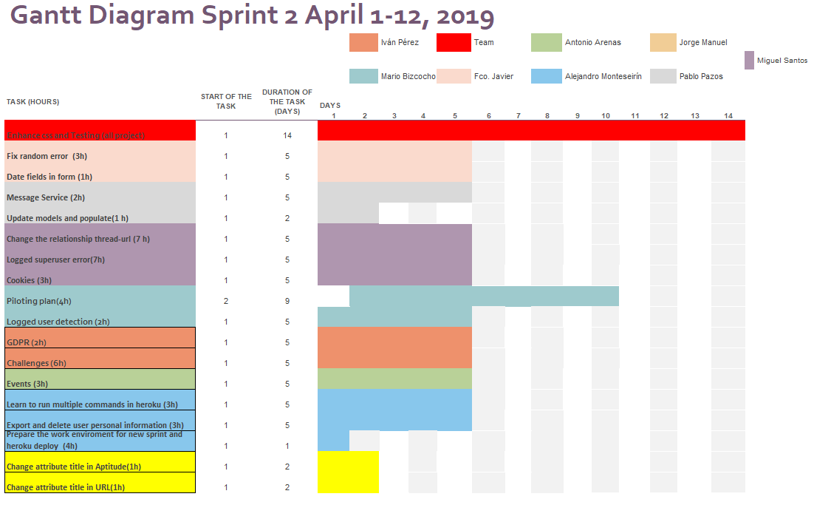

**Enhance CSS and Testing**: Everyone will test everything along the sprint and enhance the CSS

**Fix random error:** Francisco will research about and fix a random error that we get that apparently doesn't affect our app functioning

**Date fields in form**: Francisco will fix CSS in date field forms

**Message Service:** Pablo will create the messaging system for the app

**Update models and populate** Pablo will try to create a better populate script and update the models.

**Change the relationship thread-URL**: Miguel will research if it is better to change it to a collection of string instead of a relationship.

**Logged superuser error:** Miguel Will fix a bug that affect to a logged superuser when try to log in without logging out first he gets an error.

**Cookies:** Miguel will create the notification and acceptation of cookies.

**Logged user detection:** Mario will research for a better way to identify the logged user.

**GDPR**: Ivan will include the GDPR in the signup and write our terms and conditions

**Challenges**: Ivan will do the listing and create challenges by a business

**Piloting plan:** Mario and Antonio will apply the piloting plan by giving the testing app to the pilot users and getting their feedback

**Events:** Antonio will do the listing and create events by an admin.

**Learn to run multiple commands in Heroku:** Alejandro will investigate this so we can have a better populating the deployment when we need test something

**Export and delete user personal information:** Alejandro will do the functionality so the freelances can export and delete their personal information.

**Prepare the work environment for new sprint and Heroku deploy:** Alejandro will create new branches so we can properly apply Gitflow

**Control of 404 errors**: Alejandro will customize a 404-error page

**Change attribute title in Aptitude:** Jorge will change it to a descriptive name

**Change attribute title in URL**: Jorge will change it to a descriptive name

## Second Sprint execution

**We have finished with success the second sprint because we have completed all the task that we had contemplate for it.**

At the start of the second sprint we had decided to give a warning to Mario Bizcocho and Pablo Pazo, because they didn’t internationalize the business registration and we found a panic error, after we had delivered the 1º sprint.

During the second sprint we have done a sprint review at Friday 5, April to look at how is going the sprint and pinpoint the problems that have been showing up to decide what to do to get a solution.

Finishing the sprint, we have done a reunion at Friday 12 to do the sprint retrospective

The meeting minutes of both meetings are the in the attached folder Meeting Minutes.

### Principal Problems and solutions

During the development we have found some problems, but the principals ones were:

**1º Security Danger**

At the beginning of the second sprint we found a possible breach of security, this was that the only ones that could verify curricula, and create tags and graphic engines where the administrators, which is dangerous because the administrators in Django systems, have full access to everything, and it’s a danger to give this power to every person that will help in the maintenance and search of spam curricula.

So, we decided to create a new user, managers, whom have limited access to this admin panel.

**2º Problems with PowerPoint:**

At the moment of create the PowerPoint of the weekly presentation, we find a little problem, and it was that the new versions have some problems with some type of graphics with some graphic cards.

Mario Bizcocho, who is in charge of this, decided to use an old computer which hadn’t any problem with the version 365 of PowerPoint.

### Changes to the previous Second Sprint plan

After the daily meetings and sprint review, we saw the necessity add some new things

We had some changes to clarify some external tasks to the development, like the documentation and the time invested for the conference day of Jorge Manuel Molina, and to assign the task necessary to create the user Manager and who had to fix the bugs found in the testing.

### Conclusions and lessons learned from the retrospective Sprint

We have had an easy start of the spring because we had implement the great majority of the uses cases but a little more pressure at the end of it, because of some unexpected conditions of evaluation from the teachers of SEPP, that it result in a more intensive testing and fixing problems , but we could give solutions to every trouble that have been showing up and have finished the sprint satisfactorily.

We had few conflicts because we have had a good implementation of the solutions to the problems of the first sprint, and we had fount early a security risk in the system and solved it.

At the end of the meeting we had decide to forgive the warning to Mario Bizcocho and Pablo Pazo since the have worked without any problem in this sprint.

We think that we are prepared to tackle the third sprint without any problems and enhance the MVP with the feedback gained.

### Third Sprint Development Plan

To avoid a big change in any possible plan of the third sprint we will wait until the April 20 to do the Sprint planning meeting, meanwhile we will study the feedback to decided what is useful or not.

## Third Sprint Execution

**We have finished with success the third sprint because we have completed all the task that we had contemplate for it.**

We had the sprint planning during at April 20, in which we decided what we will implement from the feedback.

During the third sprint we have done a sprint review at Friday 26, April to look at how is going the sprint and pinpoint the problems that have been showing up to decide what to do to get a solution.

Finishing the sprint, we have done a reunion at Friday 03, May to do the sprint retrospective

The meeting minutes of the meetings are the in the attached folder Meeting Minutes.

### Principal Problems and solutions

During the development we had only two greater problems

**1º Communication breakdown:**

Due to exams of other subjects that have every member of the team, during the first week there wasn’t a good communication between the members and the development of this project was a secondary thing.

At the sprint review we decided to solve this, and we compromised to work more to avoid the danger of not finish the development, and communicate more, this was possible because no one had exams in the second week, and we have finished the sprint without problems

**2º PayPal payment recognition:**

During the change in the pay model we found that if someone payed by PayPal but didn’t return to our web and closed the payment window, our system didn’t recognize the payment, because we checked the payment in the return.

Now we implement IPN (Instant Payment Notification) every payment and have solved this problem.

### Third Sprint Development Plan

After the Sprint planning meeting we decided the next tasks:

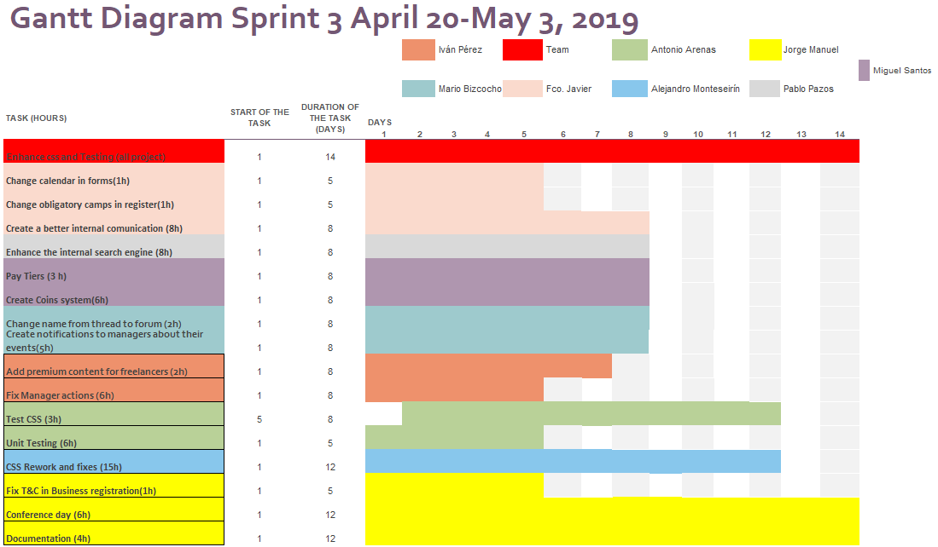

**Enhance CSS and Testing**: Everyone will test everything along the sprint and enhance the CSS

**Change calendar in forms:** Francisco change the way in which one can enter a date in a form

**Change obligatory field in register**: Francisco will the obligation to fill some fields in forms, like URL etc.

**Create a better internal communication**: Francisco will change the actual internal message system to a chat one.

**Enhance the internal search engine:** Pablo will enhance the search engine, so everything is searchable

**Pay Tiers**: Miguel will research the different payment tiers for business

**Create Coins system:** Miguel create the new coin system that is related with the new payment tiers.

**Change name from Thread to Forum:** Mario will change these words so is more intuitive for business.

**Create notification to managers about their events:** Mario will create a system, so every manager is informed about every change in their events.

**Add premium content for freelancers**: Ivan will create the option to freelancers for benefits for their curriculums

**Fix Manager actions**: Ivan fix some actions of Manager

**Test CSS:** Antonio will test every new CSS that Alejandro do.

**Unit Testing:** Antonio will create the Unit tests.

**CSS rework and fixes:** Alejandro will change the CSS following the recommendations from the piloting plan

**Fix T&C in business registration:** Jorge will fix the option in the business registration.

**Conference day**: Jorge will be in charge of this.

**Documentation**: Jorge will be in charge of this.

### Conclusions and lessons learned from the retrospective sprint

We have had a little chaotic start of the spring because we everyone had obligations with exams of other subjects so the development of the project was secondary, and the team communication was low, but we could solve this near the end of the first week.

Solved this we had a smoot sprint, and with only a little problem with payment with PayPal, finished in time.

We think that we are prepared to tackle the last part of this project, finish the business plan and prepare the launch day.

# Technologies

Our platform is based in Django python, which with the support of materialize.css for the frontend, allowing us to create a beautiful web design, very dynamic and totally responsive.

Our Database is PostgreSQL which is a powerful open source object-relational database and has a very easy and stable integration in Heroku.

For the deployment we will use Heroku, which is a cloud platform service that also offer a good scalability.

As for payments, we will use the PayPal API because of its simplicity and free developer access.

We decided in these technologies because we have experience with every of them but Django, but we have started a learning plan to solve that risk.

We will use Travis CI for automatic testing in the development, which is a system that run our Unit Test every time that we want to push something to the repository, so we can detect any bug.

And we will use Google Lighthouse for efficiency code, which is an addon for google chrome that give us metrics about the effectivity of our code and how good is our web system.

# Quality Report

The report from Google lighthouse is the attached file “Lighthouse Report” where we have got a positive note, but not perfect. And we will use for a future planning of other projects of how we can get better code.

# Team Composition

Our team is composed by:

**Project manager**: Fco. Javier de la Fuente is the team leader, in charge of the project review and guidance, also he must encourage the rest of the team and take actions if anyone is not correctly working. He lacks technology knowledge but compensate his inexperience in programming with strong management and talking skills.

**CCO/CIO**: Jorge Manuel Molina Dominguez oversees the interactions with other groups of ISPP and the documentation, he also communicates with all teams and help to organise the knowledge base, he also is in charge of the testing and the DB population of the platform.

**Speaker/CMO**: Mario Bizcocho Gonzalez, in charge of the marketing and sales department of the platform, he has a high English level and very high socials skills, he also helps in the backend programming.

**Full-Stack-Developers**: First we have Alejandro Monteseirin Puig, probably the most skilled and experienced member of the team with the technologies, with more than a year of experience with materialize.css frontend and a lot of knowledge in Django, PostgreSQL and Heroku, he is responsible of the correctly working of the deploy and the platform in general.

Also, we have Miguel Santos Batista, who also have good programming skills and experience, he works with Alejandro in the main process of building of the platform.

**Backend developers**: Ivan Perez Piñero and Pablo Pazo Jimenez are in charge of the backend, they got less experience than our Full-Stack-Developers, but they will be supported by them constantly.

**Frontend developer**: Antonio Arenas, who have tons of experience in the frontend development and will be in charge of the frontend side of the platform, he also is responsible of the intuitive and responsive design of the platform.

## Explanation of slide of team composition of the attached PowerPoint

We want to clarify the 3 values of these slides.

The first one, the little hand, is the productivity of that member in the sprint.

The second one, the clock, is the hours invested/predicted hours needed for all his development, no management, tasks.

The third one, is a visual representation of the second value.

The second and third value don’t have real importance but to help to measure better the assigned time to the different tasks of a sprint

# Productivity metric and Punishment System

## Productivity metric

Productivity is related with the number of completed task that have been completed and are in revision at any moment of the sprint.

We use:

$\frac{{∑P}_{i}+∑0.75*p_{j}}{N}*100=η_{p}$

P is the number of completed assigned tasks

p is the number of tasks that are in revision

N is the total assigned tasks to that member

ηp is the productivity.

With this formula we can get values from 0 to 100, being 100 the ideal, with this formula we can study the production of a person at any moment of the sprint and see if we need any measure to avoid any danger to the sprint.

If ηp < ), of any member at any moment of the sprint, it will mean that have a low productivity and must to take steps to solver it or will be in danger to receive a warning.

With this every member must have a productivity of 100 (all task completed) at the last day of sprint, and this value will be reset at the start of every sprint.

## Punishment System

We have defined a Warning methodology.

Anyone can say that other deserve a Warning because he hasn’t worked or has affect negatively to the project along this sprint and call for vote, if the half plus one of the team say 'yes', the person get a Warning. The vote must be done at review or retrospective meeting.

If someone get 3 warnings that member is expelled from the team, exceptionally if someone that have 1 warning, can be expulsed if 80% of the team vote to favour and if only that person have done something too grave.

You can lose a warning if a member completes without any problem all his tasks in any sprint.

# Pilot study

We have 3 studios and 3 users that have compromised to test in a pilot plan our application, look attached folder “Pilot agreement” for their contracts.

## Studios

**Rafael Sánchez Cadena (TieSoft):** Rafael graduated in Architectural Engineering at the University of Seville in 2008 and got into game making in 2014. He leads the development of “Inexplicable Deaths in Damipolis” at his studio in La Cartuja and is currently finishing the game demo. It is expected to come out in June, and the marketing campaign will start in the second half of March.

**Daniel Jesús Marín Jurado (Dual Mirror Games)** oversees Marketing and PR for Dual Mirror Games, the makers of the first-person space-combat game Readout: First Contact. The game is currently in development and without a set release date and is hosted in the same coworking space as TieSoft’s.

**Rafael Casaucao Aguilar (Gunstar Studio)** is the CEO and lead game designer for Gunstar Studio, makers of the already released Phobos Vector Prime. This is a top-down bullet hell game where you survive waves of enemies, and it has garnered a moderate following in its PS4 release. The studio is currently working on several smaller projects to gather financing for the next big endeavour.

## Users

**Alberto Sánchez** is the vice president of AIM Games, and student of Information Technologies at the University of Seville. He’s currently in his third year of studies and looking for internships, with eyes set on carrying them out at TieSoft. He’s already collaborated with them in several cases, mostly in bug fixing.

**Vinnicios Thyago Dias Taufner** is a member of the directive board at Serious Games, the University of Seville’s game development association, and is in his fourth year of studies at Computer Engineering. He’s carrying out his internship at Fujitsu, but had he known about the existence of established independent game studios in Seville, he’d have chosen them over Fujitsu even for a lower retribution. He’s got double Spanish-Brazilian nationality.

**Francisco Javier Sánchez Gata** is AIM Games’ secretary and member of the board of directives at Serious Games. He is in his fourth year of Computer Engineering studies at the University of Seville, and lives in a student flat in Bami since he is natural of Extremadura. He has collaborated on occasions with TieSoft and is looking for a second company for his actual internship.

## Open Beta

We also plan for an open beta testing in which we will try to get the opinion of 50 or more people about the design of the application to try to create the best possible intuitive design with the feedback.

# Piloting Plan

The piloting plan and its results are in the attached document “Piloting plan and results”

## Overview of the decided changes from the feedback

After studying the feedback, we have decided the next changes:

-User pictures should not be mandatory

- Coin system for challenges & offers, subscription models

-Better search functionality

-Aesthetical fixes

Other changes that we could do when we have finished SEPP, and decided to carry out the project in a serious enterprise could be:

-Answers to challenges listed by challenger

-Explain what challenges are.

-Free business demo

-Tags on events.

# Competitor analysis

We will launch our platform in a market where it won’t be alone, in this sector we found some competitors with whom we will have to deal to get our niche market. In our analysis, we compare our platform with other 11 websites or platforms that offers services like ours.

In this document we will keep in mind 9 features that our platform will have. The features are: a forum where base members and companies can talk, the verified CV service, the resource database, the direct message service, the courses section, the existence of companies' profiles, the sector focus, create challenges and participate events.

We will take this chart as starting point and explain in detail our differences with these platforms:

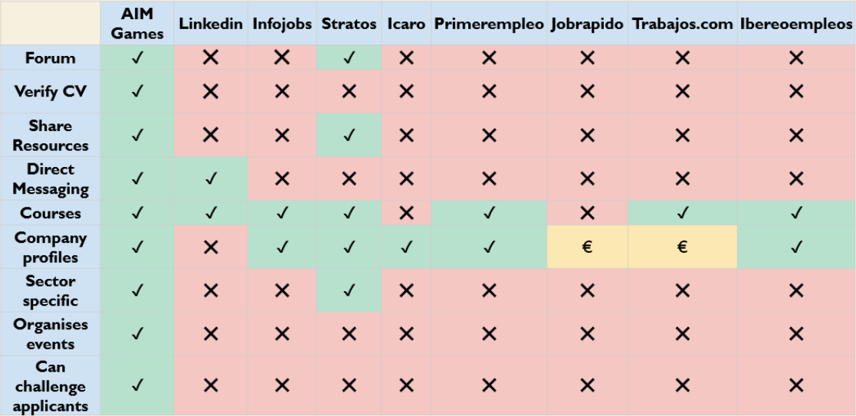

Our first competitor is Linkedin, in this platform workers can post their curricula and the legal representative of the companies can talk with them for negotiate a contract, also they offer courses in their platform. But Linkedin is not sector focused, they don't verify CV data and don’t have a resource database or forum either.

The second one is Infojobs, this platform is very similar to Linkedin, the only difference is that Linkedin the legal representative profiles while in Infojobs we found the companies’ profiles, Infojobs don’t have a direct message service either.

Now we will look to Stratos, maybe our biggest competitor because is the only one focused in our sector but they don’t verify the CV Data or have a direct message system like us. It is important to highlightthat the website looks very outdated and we can take advantage from that.

In the next tier we found Icaro is a platform to internships, it isn’t a big competitor since its only feature is the companies’ profiles and they are very insecure.

At the same level that Infojobs we found some platforms that offers the same features as Infojobs, they are Iberoempleos, Primerempleo or trabajos.com. Trabajos.com is slightly different since the company's profiles are a premium mode feature.

And last, we have Jobrapido, that only offers the company profile in their premium mode and is the least threatening competition.

About the last two features that have not been commented, create challenges and participate at events, we see that no one offers them and it’s these two features the more attractive of them because it’s something that are not normally carried out in this type of web services.

# Differentiation

Our platform will search the way to differentiate from our competitors, and we will make that difference based on 4 key points: an intuitive design, a credibility assurance, searchability and the collaboration between members and companies.

The first key point that will make the difference is an intuitive design under the members and companies will be able to navigate in a useful, functional and easy to use platform, doing easier every operation they could be able to do in our platform.

We will offer a credibility assurance that will secure that every CV will be genuine, so no member will be able to cheat in their CV and affect some company that could hire him to do some jobs and we will prevent that any member could upload any malicious file to our forums.

Another key point will be our searchability, our search engine will be an easy way to access any registry in our database and will provide a heuristic for providing the most relevant results first better than other platforms.

In our forums, the association’ members and the companies will collaborate to make a bigger knowledge that will help other members or companies, exchanging technological resources or ideas.

With the challenges the business will have the opportunity to dare the freelancers to resolve any problems for some prize, contract, etc… This will allow for to make a pre-job interview filters or promote any technology or the community itself.

Our last big differentiation is that we are an association, one that search to promote every member and videogames, so we will organize different events like game jams, events like hackathons but for create videogames where business can look for new talents, or game fairs to promote the indie videogames, etc…

# GDRP

Our system obeys the new GDRP law

We have a link to our T&C at the footer of the web, where is everything explained with simple wording.

If any user or customer desired it, he or she export all the information that the system have about him or her in a simple txt.

Or he and she can automatically delete all his/her account and all information from the system.

If at any problem there is a security breach in our system, the administrators will send messages to every user/customer.

And about the Data protection officer we will not hire nobody for the moment, but we will study their cost in the near future during the next iteration.

# Code repository and deployed application

The code repository and deployed application URLs, and every necessary account are in the attached document “README”

# Charter of commitment

Every member of this team is committed to carry out the project with the goal of success with the highest quality possible and never give up in the face of adversity.

**De la Fuente Bonilla, Fco. Javier Pérez Piñero, Iván**

**Arenas Arenas, Antonio Molina Domínguez, Jorge Manuel**

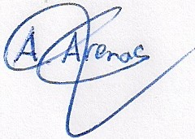

**Monteseirín Puig, Alejandro Bizcocho González, Mario**

**Santos Batista, Miguel Pazo Jiménez, Pablo**

# Signed in conformity

